¹H NMR spectra (500 MHz, CD₂Cl₂, -15°C) of (from above)
- Canthaxanthin treated with CF₃COOD from Acros, providing monocations 9, 10, 12, 13.
- Canthaxanthin treated with CF₃COOD from Sigma, providing monocations 9 and 10.
- Canthaxanthin treated with CF₃SO₃D, providing trication 14.

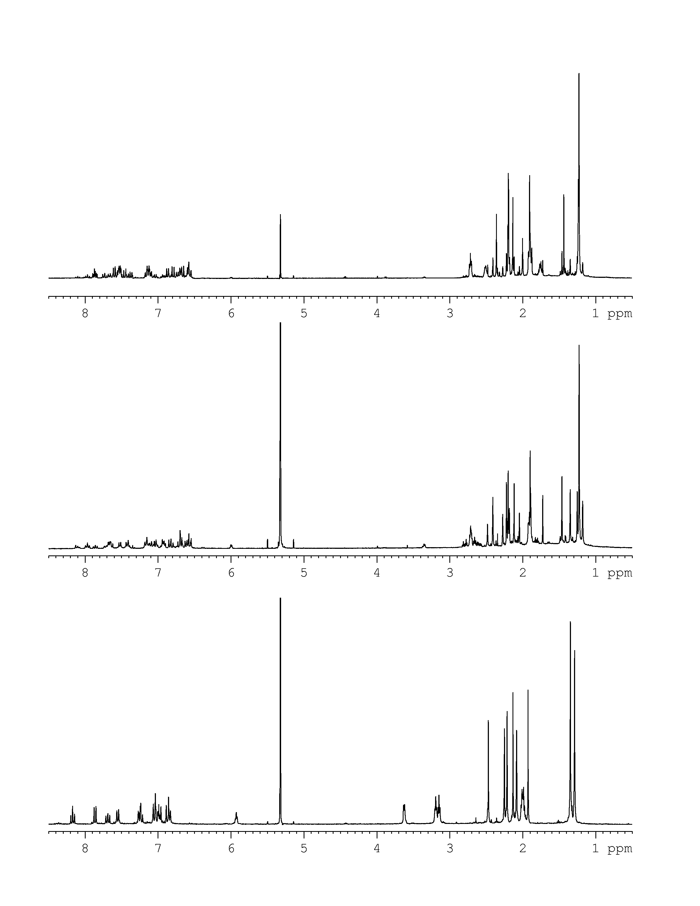

Expansion of low-field part of ¹H NMR spectra.
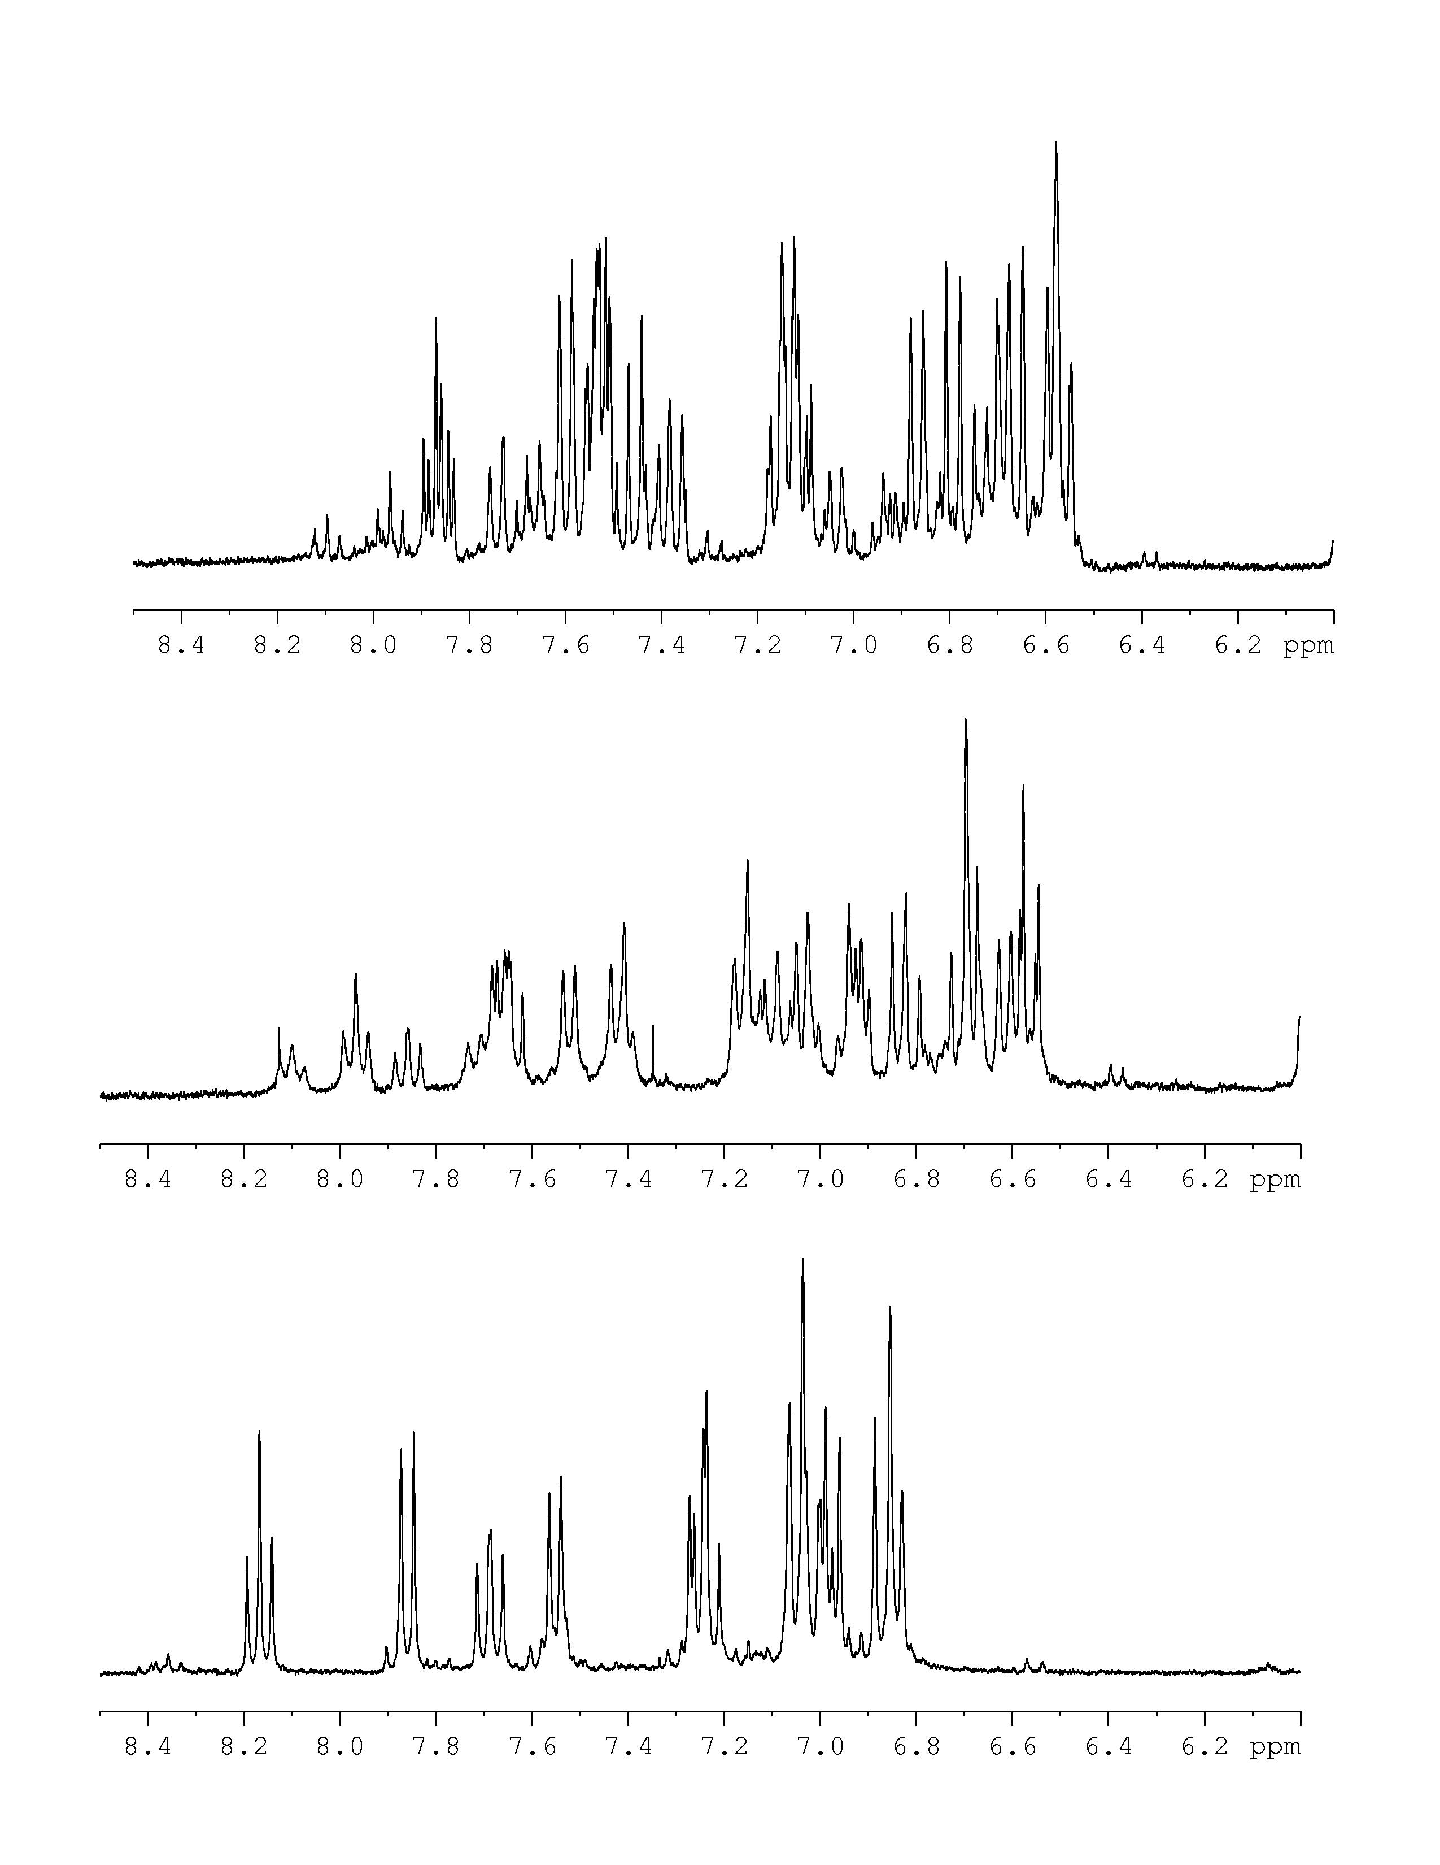

Expansion of high-field part of ¹H NMR spectra.
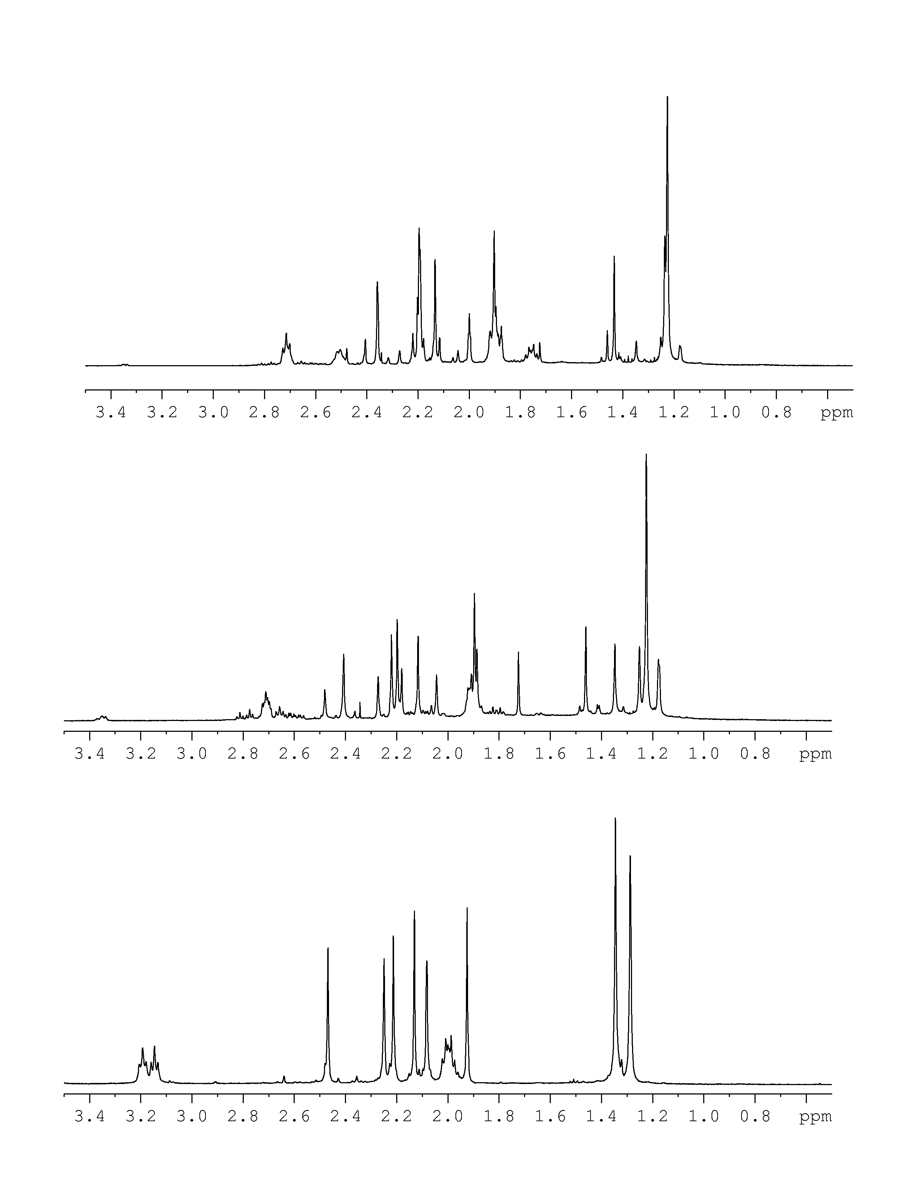

2D ROESY spectrum of the trikation 14.

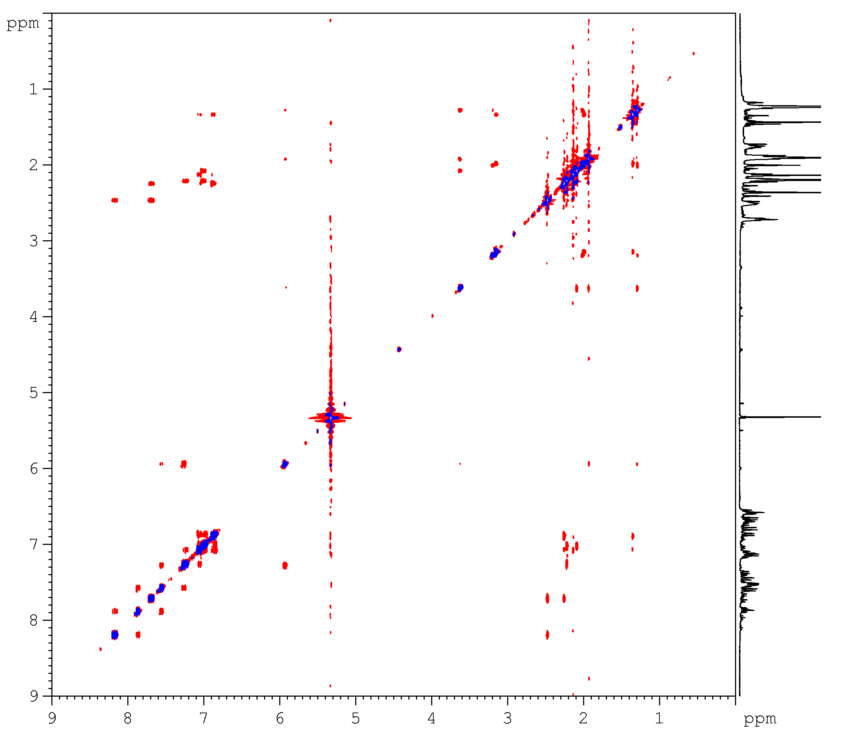

2D ROESY spectrum of the monocation 9 and 10, prepared from canthaxanthin by treatment with CF₃COOD from Sigma.
